IVD Guideline

Key recommendation

Preparation for assisted vaginal birth / Instrumental vaginal delivery/Operative vaginal delivery

Continuous support during labour can reduce the need for assisted vaginal birth.

Epidural analgesia may increase the need for assisted vaginal birth although this is less likely with newer analgesic techniques. [New 2020]

Epidural analgesia in the latent phase of labour compared to the active phase of labour does not increase the risk of assisted vaginal birth. [New 2020]

Women not using epidural adopting upright or lateral positions in the second stage of labour as this reduces the need for assisted vaginal birth.

Women using epidural analgesia adopting lying down lateral positions rather than upright positions in the second stage of labour increases the rate of spontaneous vaginal birth. [New 2020

Delayed pushing for 1-2 hours in nulliparous women with epidural analgesia reduce the need for rotational and midpelvic assisted vaginal birth.

Do not routinely discontinue epidural analgesia during pushing as this increases the woman's pain with no evidence of a reduction in the incidence of assisted vaginal birth. [New 2020]

There is insufficient evidence to recommend any particular regional analgesia technique in terms of reducing the incidence of assisted vaginal birth. [New 2020]

There is insufficient evidence to recommend routine oxytocin augmentation for women with epidural analgesia as a strategy to reduce the incidence of IVD/OVD.[New 2020]

There is insufficient evidence to recommend routine prophylactic manual rotation of fetal malposition in the second stage of labour to reduce the risk of assisted vaginal birth. [New 2020)

Use a standard classification system for assisted vaginal birth to promote safe clinical practice, effective communication between health professionals and audit of outcomes.

Operators should be aware that no indication is absolute and that clinical judgment is required in all situations.

Suspected fetal bleeding disorders or a predisposition to fracture are relative contraindications to assisted vaginal birth. [New 2020]

Blood borne viral infections in the woman are not an absolute contraindication to assisted vaginal birth. [New 2020]

The use of a vacuum is not contraindicated following a fetal blood sampling procedure or application of a fetal scalp electrode. [New 2020]

Operators should be aware that there is a higher risk of subgaleal haemorrhage and scalp trauma with vacuum extraction compared with forceps at preterm gestational ages. Vacuum birth should be avoided below 32 weeks of gestation and should be used with caution between 32*° and 36*° weeks of gestation. [New 2020

Safe assisted vaginal birth requires a careful assessment of the clinical situation, clear communication with the woman and healthcare personnel, and expertise in the chosen procedure (Table 3).

Ultrasound assessment of the fetal head position prior to assisted vaginal birth is recommended where uncertainty exists following clinical examination. (New 2020)

There is insufficient evidence to recommend the routine use of abdominal or perineal ultrasound for assessment of the station, flexion and descent of the fetal head in the second stage of labour. [New 2020)

Women should be informed about assisted vaginal birth in the antenatal period, especially during their first pregnancy. If they indicate specific restrictions or preferences then this should be explored with an experienced obstetrician, ideally in advance of labour.

For birth room procedures verbal consent should be obtained prior to assisted vaginal birth and the discussion should be documented in the notes.

When midpelvic or rotational birth is indicated, the risks and benefits of assisted vaginal birth should be compared with the risks and benefits of second stage caesarean birth for the given circumstances and skills of the operator. Written consent should be obtained for a trial of assisted vaginal birth in an operating theatre. [New 2020)

Performing assisted vaginal birth

Assisted vaginal birth should be performed by, or in the presence of, an operator who has the knowledge, skills and experience necessary to assess the woman, complete the procedure and manage any complications that arise.

Advise obstetric trainees to achieve expertise in spontaneous vaginal birth prior to commencing training in assisted vaginal birth.

Ensure obstetric trainees receive appropriate training in vacuum and forceps birth, including theoretical knowledge, simulation training and clinical training under direct supervision. [New 2020]

Competency should be demonstrated before conducting unsupervised births. [New 2020]

Complex assisted vaginal births should only be performed by experienced operators or under the direct supervision of an experienced operator.

An experienced operator, competent at midpelvic births, should be present from the outset to supervise all attempts at rotational or midpelvic assisted vagina.

Non-rotational low-pelvic and if out assisted vaginal births have a low probability of failure and most procedures can be conducted safely in a birth room. [New 2020)

Assisted vaginal births that have a higher risk of fallure should be considered a trial and be attempted in a place where immediate recourse to caesarean birth can be undertaken.

The operator should choose the instrument most appropriate to the clinical circumstances and

their level of skill.

Operators should be aware that forceps and vacuum extraction are associated with different benefits and risks; failure to complete the birth with a single instrument is more likely with vacuum extraction, but maternal perineal trauma is more likely with forceps. [New 2020]

Operators should be aware that soft cup vacuum extractors have a higher rate of failure but a lower incidence of neonatal scalp trauma. [New 2020)

Rotational births should be performed by experienced operators; the choice of instrument depending on the clinical circumstances and expertise of the individual. The options include Kielland's rotational forceps, manual rotation followed by direct traction forceps or vacuum, and rotational vacuum extraction.

Discontinue vacuum-assisted birth where there is no evidence of progressive descent with moderate traction during each pull of a correctly applied instrument by an experienced operator. [New 2020)

Complete vacuum-assisted birth in the majority of cases with a maximum of three pulls to bring the fetal head on to the perineum. Three additional gentle pulls can be used to ease the head out of the perineum. [New 2020)

If there is minimal descent with the first two pulls of a vacuum, the operator should consider whether the application is suboptimal, the fetal position has been incorrectly diagnosed or there is cephalo pelvic disproportion .Less experienced operator should stop and seek a 2nd opinion .Experienced operators should re-evaluate the clinical findings and either change approach or discontinue the procedure. [New 2020]

Discontinue vacuum-assisted birth if there have been two 'pop-offs' of the instrument. Less experienced operators should seek senior support after one 'pop-off' to ensure the woman has the best chance of a successful assisted vaginal birth. [New 2020]

The rapid negative pressure application for vacuum-assisted birth is recommended as it reduces the duration of the procedure with no difference in maternal and neonatal outcomes. [New 2020]

The use of sequential instruments is associated with an increased risk of trauma to the infant.

However, the operator needs to balance the risks of a caesarean birth following failed vacuum extraction with the risks of forceps birth following failed vacuum extraction.

Obstetricians should be aware of the increased neonatal morbidity following failed vacuum-assisted birth and/or sequential use of instruments, and should inform the neonatologist when this occurs to ensure appropriate care of the baby.

Obstetricians should be aware of the increased risk of obstetric anal sphincter injury (OASI) following sequential use of instruments. [New 2020]

Discontinue attempted forceps birth where the forceps cannot be applied easily, the handles do not approximate easily or if there is a lack of progressive descent with moderate traction. [New 2020]

Discontinue rotational forceps birth if rotation is not easily achieved with gentle pressure. [New 2020]

Discontinue attempted forceps birth if birth is not imminent following three pulls of a correctly applied instrument by an experienced operator. [New 2020]

If there is minimal descent with the first one or two pulls of the forceps, the operator should consider whether the application is suboptimal, the position has been incorrectly diagnosed or there is cephalopelvic disproportion. Less experienced operators should stop and seek a second opinion. Experienced operators should re-evaluate the clinical findings and either change approach or discontinue the procedure. [New 2020)

Obstetricians should be aware of the potential neonatal morbidity following a failed attempt at forceps birth and should inform the neonatologist when this occurs to ensure appropriate management of the baby. [New 2020]

Obstetricians should be aware of the increased risk of fetal head impaction at caesarean birth following a failed attempt at birth via forceps and should be prepared to disimpact the fetal head using recognised manoeuvres. [New 2020]

Mediolateral episiotomy should be discussed with the woman as part of the preparation for assisted vaginal birth. [New 2020]

in the absence of robust evidence to support either routine or restrictive use of episiotomy at assisted vaginal birth, the decision should be tallored to the circumstances at the time and the preferences of the woman. The evidence to support use of mediolateral episiotomy at assisted vaginal birth in terms of preventing OASI is stronger for nulliparous women and for birth via forceps. [New 2020]

When performing a mediolateral episiotomy the cut should be at a 60 degree angle initiated when the head is distending the perineum. [New 2020)

Aftercare following assisted vaginal birth

A single prophylactic dose of intravenous amoxicillin and clavulanic acid should be recommended following assisted vaginal birth as it significantly reduces confirmed or suspected maternal infection compared to placebo. [New 2020]

Good standards of hygiene and aseptic techniques are recommended.

Reassess women after assisted vaginal birth for venous thromboembolism risk and the need for thromboprophylaxis.

In the absence of contraindications, women should be offered regular nonsteroidal anti-inflammatory drugs (NSAIDs) and paracetamol routinely .

Women should be educated about the risk of urinary retention so that they are aware of the importance of bladder emptying in the postpartum period. [New 2020]

The timing and volume of the first void urine should be monitored and documented.

[New 2020]

A post void residual should be measured if urinary retention is suspected.

Recommend that women who have received regional analgesia for a trial of assisted vaginal birth in theatre have an indwelling catheter in situ after the birth to prevent covert urinary retention. This should be removed according to the local protocol. [New 2020]

Offer women physiotherapy-directed strategies to reduce the risk of urinary incontinence at 3 months.

Shared decision making, good communication, and positive continuous support during labour and birth have the potential to reduce psychological morbidity following birth. [New 2020]

Review women before hospital discharge to discuss the indication for assisted vaginal birth, management of any complications and advice for future births. Best practice is where the woman is reviewed by the obstetrician who performed the procedure.

Offer advice and support to women who have had a traumatic birth and wish to talk about their experience. The effect on the birth partner should also be considered. [New 2020]

Do not offer single session, high-intensity psychological interventions with an explicit focus on

reliving the trauma. [New 2020]

Offer women with persistent post-traumatic stress disorder (PTSD) symptoms at 1 month referral to skilled professionals as per the NICE guidance on PTSD. [New 2020]

Inform women that there is a high probability of a spontaneous vaginal birth in subsequent labours following assisted vaginal birth. [New 2020]

Individualise care for women who have sustained a third or fourth-degree perineal tear, or who have ongoing pelvic floor morbidity.

Governance issues

Documentation for assisted vaginal birth should include detailed information on the assessment, decision making and conduct of the procedure, a plan for postnatal care and sufficient information for counselling in relation to subsequent pregnancies. Use of a standardised proforma is recommended. [New 2020]

Paired cord blood samples should be processed and recorded following all attempts at assisted vaginal birth. [New 2020]

Adverse outcomes, including unsuccessful assisted vaginal birth, major obstetric haemorrhage, OASI, shoulder dystocia and significant neonatal complications should trigger an incident report as part of effective risk management processes. [New 2020]

Obstetricians should ensure that the ongoing care of the woman, baby and family is paramount. [New 2020]

Obstetricians have a duty of candour; a professional responsibility to be honest with patients when things go wrong. [New 2020)

Obstetricians should contribute to adverse event reporting, confidential enquiries, and take part in regular reviews and audits. They should respond constructively to outcomes of reviews, taking necessary steps to address any problems and carry out further retraining where needed.

[New 2020]

Maternity units should provide a safe and supportive framework to support women, their families and staff when serious adverse events occur. [New 2020]

Assisted vaginal birth by vacuum or forceps is used to assist birth for maternal and fetal indications. In the UK, between 10% and 15% of all women give birth by assisted vaginal birth.' Almost one in every three nulliparous women gives birth by vacuum or forceps, with lower rates in midwifery-led care settings23 There has been a rise in the rate of caesarean births in the second stage of labour; this may reflect concerns about assisted vaginal birth morbidity or a loss of clinical skills.*

TABLE 1

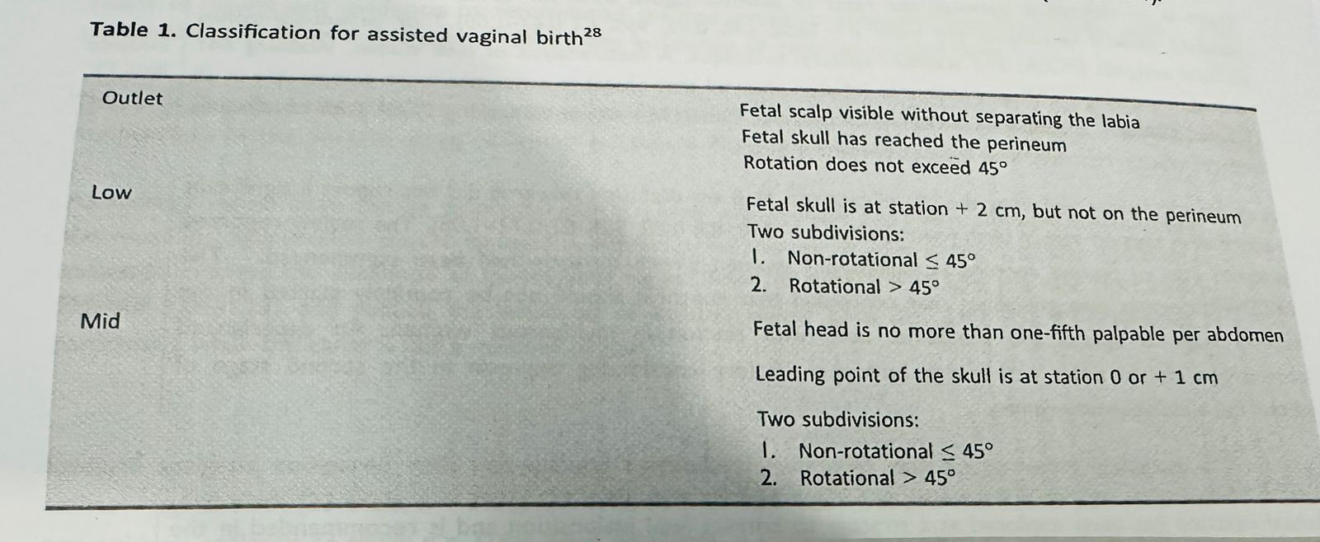

TABLE 2

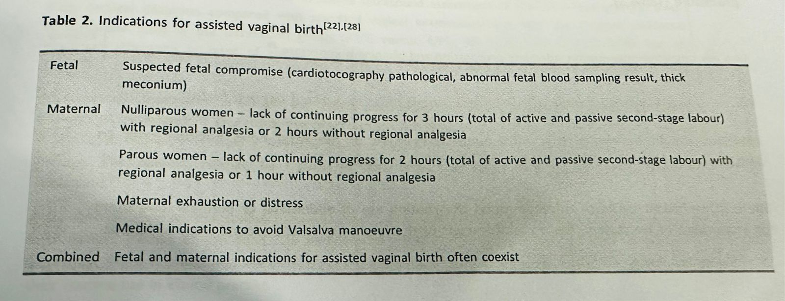

TABLE 3

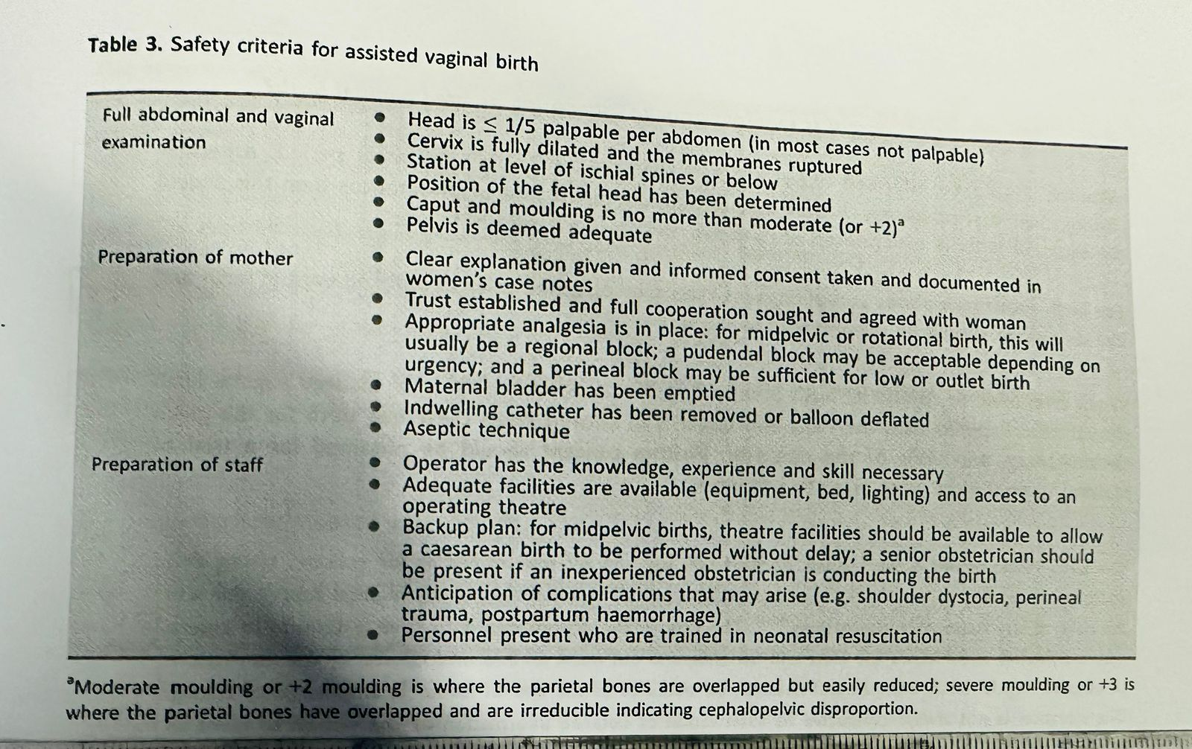

Higher rates of failure are associated with:

* maternal BMI greater than 30

* short maternal stature

* estimated fetal weight of greater than 4 kg or a clinically big baby

* head circumference above the 95th percentile

* occipito-posterior position

* midpelvic birth or when one-fifth of the head is palpable per abdomen.

TABLE 4

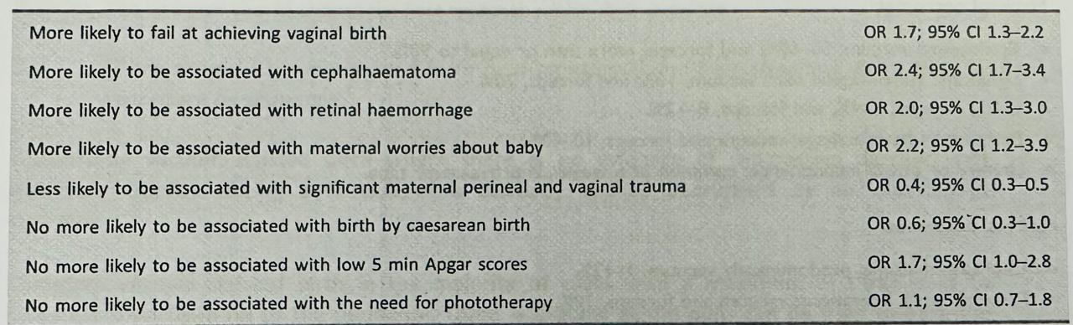

Risk-based information can be summarised as follows:"

Maternal outcomes:

* Episiotomy, vacuum, 50-60%; and forceps, more than or equal to 90%.

* Significant vulvo-vaginal tear; vacuum, 10%; and forceps, 20%.

* OASI; vacuum, 1-4%; and forceps, 8-12%.

* Postpartum haemorrhage; vacuum and forceps, 10-40%.

* Urinary or bowel incontinence; common at 6 weeks, improves over time.

Perinatal outcomes:

* Cephalhaematoma; predominantly vacuum, 1-12%.

* Facial or scalp lacerations; vacuum and forceps, 10%.

Retinal haemorrhage; more common with vacuum than forceps, variable 17-38%.

Jaundice or hyperbilirubinaemia; vacuum and forceps, 5-15%.

* Subgaleal haemorrhage; predominantly vacuum, 3 to 6 in 1000.

* Intracranial haemorrhage; vacuum and forceps, 5 to 15 in 10 000.

* Cervical spine injury; mainly Kiellands rotational forceps, rare.

* Skull fracture; mainly forceps, rare.

* Facial nerve palsy; mainly forceps, rare.

* Fetal death; very rare.

NVD/INTRAPARTUM CARE Guideline

Service organization

* Commissioners and providers, including networks of providers, should ensure that all 4 birth settings (home, freestanding midwifery unit, alongside midwifery unit and obstetric unit) are available to all women (in the local area or in a neighbouring area). [2014, amended 2023)

* Ensure that all women giving birth have timely access to an obstetric unit if they need transfer of care for medical reasons or because they request regional analgesia. Audit and publish transfer times and reasons for delay in transfers so women can be informed of local service availability. [2014. amended 2023]

* Commissioners and providers, including networks of providers, should ensure that there are:

robust protocols in place for transfer of care between settings clear local pathways for the continued care of women who are

transferred from one setting to another, including: o when crossing provider boundaries

* if the nearest obstetric or neonatal unit is closed to admissions or the local midwifery-led unit is full. (2014]

* Commissioners and providers, including networks of providers, should ensure that there are multidisciplinary clinical governance structures in place to enable the oversight of all birth settings. These structures should include, as a minimum, midwifery, obstetric, anaesthetic and neonatal expertise, and adequately supported user representation. [2014 amended 2023J

Planning place of birth

* All women at low risk of complications

* Explain to both multiparous and nulliparous women who are at low risk of complications that giving birth is generally very safe for both the woman and her baby .2014

Advise women that additional resources to help them plan their place of birth are available on the tools and resources page for this guideline and the NHS website. (2023]

* Explain to both multiparous and nulliparous women that they may choose any birth setting (home, freestanding midwifery unit, alongside midwifery unit or obstetric unit), and support them in their choice of setting wherever they choose to give birth:

Advise low risk multiparous women that planning to give birth at home or in a midwifery-led unit (freestanding or alongside) is associated with a lower rate of interventions and the outcome for the baby is no different compared with an obstetric unit.

Advise low-risk nulliparous women that planning to give birth in a midwiferyled unit (freestanding or alongside) is associated with a lower rate of interventions and the outcome for the baby is no different compared with an obstetric unit. Explain that if they plan birth at home, there is a small increase in the risk of an adverse outcome for the baby. [2014, amended 2023]

* Ensure that all"healthcare professionals involved in the care of pregnant women are familiar with the types and frequencies of serious medical problems that can affect babies in order to be able to provide this information to women if they request it. (2014]

* Discuss with women the following information, including local statistics, about all local birth settings, and update them if this changes during their pregnancy:

access to midwives, including:

* the likelihood of being cared for in labour by a familiar midwife

* the likelihood of receiving one-to-one care throughout labour (not necessarily being cared for by the same midwife for the whole of labour)

access to medical staff (obstetric, anaesthetic and neonatal) availability of birthing pools

access to pain relief, including Entonox (a 50:50 mixture of oxygen and nitrous oxide) and medicines (for example, pethidine, diamorphine, patientcontrolled analgesia and regional analgesia)

the likelihood of being transferred to an obstetric unit (if this is not the woman's chosen place of birth), the reasons why this might happen, the time it may take, the delay in obstetric or neonatal care this may cause, and how her birth companion will travel; refer to table 1 if no local data is available.

Table 1 Primary reasons for transfer to an obstetric unit by number of women transferred (% of total transferred from each setting)

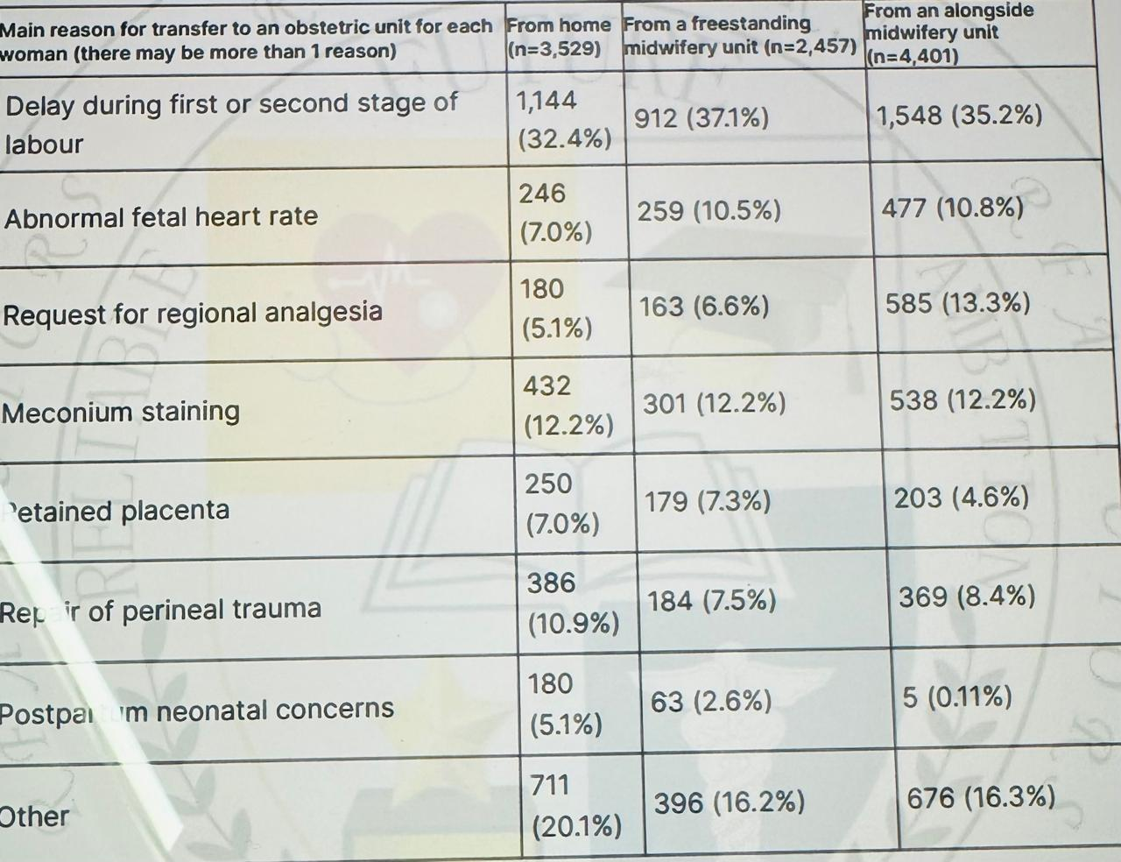

Impact of BMI on choice of place of birth

* Advise vomen that, in general, the higher their body mass index (BMI) at booking (and particularly with a BMI above 35 kg/m2 ), the greater the likelihood of complications, so this may be something they wish to think about when planning their place of birth. Discuss with them that:

these complications include unplanned caesarean birth postpartum haemorrhage, transfer from home to an obstetric unit, stillbirth, neonatal death or the baby needing neonatal care

the risk of complications may depend on whether the woman is nulliparous or multiparous, but in general the risks of complications are higher for nulliparous women with an increased BMI compared with multiparous women with an increased BMI

in the event of complications arising, advanced care can generally be given more quickly in an obstetric unit or an alongside midwifery unit than at home or in a freestanding midwifery unit

Low-risk multiparous women

* Using tables 2 and 3, explain to low-risk multiparous women that:

planning birth at home or in a freestanding midwifery unit is associated with a higher rate of spontaneous vaginal birth than planning birth in an alongside midwifery unit, and these 3 settings are associated with higher rates of spontaneous vaginal birth than planning birth in an obstetric unit

planning birth in an obstetric unit is associated with a higher rate of interventions, such as vaginal birth with forceps or ventouse, unplanned caesarean birth and episiotomy, compared with planning birth in other settings

there are no differences in outcomes for the baby associated with planning birth in any setting. [2014, amended 2023]

Table 2 Low-risk multiparous women: Rates of different modes of birth, transfer to an obstetric unit and obstetric interventions for each planned place of birth (number of incidences per 1,000 women giving birth by location)

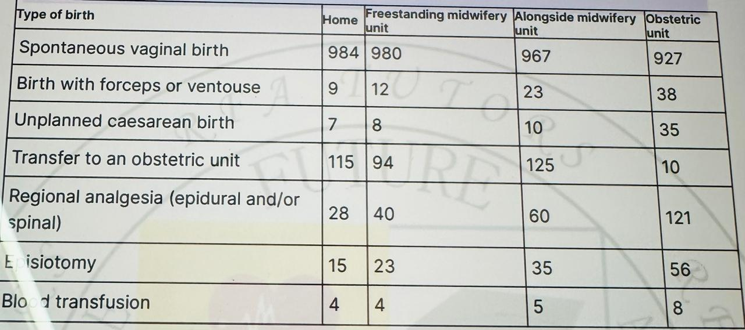

* For obstetric unit transfer to an obstetric unit, the 10 cases noted in table 2 are the estimated transfer rate from one obstetric unit to a different obstetric unit owing to lack of capacity or expertise. For regional anesthesia, Blix et al. reported epidural analgesia and the Birthplace in England study reported spinal or epidural analgesia.

Table Low-risk multiparous women: Outcomes for the baby for each planned place of birth (by number of babies per 1,000 births)

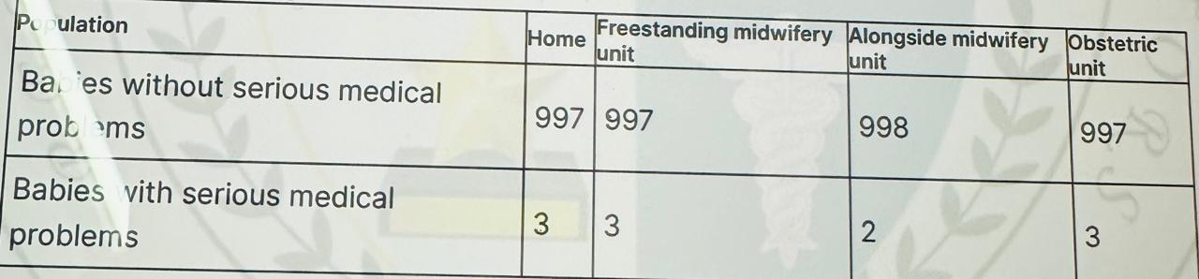

* Serious medical problems were combined in table 3: neonatal encephalopathy and meconium aspiration syndrome were the most common adverse events, together accounting for 75% of the total.

Stillbirths after the start of care in labour and death of the baby in the first week of life accounted for 13% of the events. Fractured humerus and clavicle were uncommon outcomes (less than 4% of adverse events).

Low-risk nulliparous women

* Using tables 4 and 5, explain to low-risk nulliparous women that: planning birth at home or in a freestanding midwifery unit is associated with a higher rate of spontaneous vaginal birth than planning birth in an alongside midwifery unit, and these 3 settings are associated with higher rates of spontaneous vaginal birth than planning birth in an obstetric unit

planning birth in an obstetric unit is associated with a higher rate of interventions, such as vaginal birth with forceps or ventouse, planned caesarean birth and episiotomy, compared with planning birth in other settings

there are no differences in outcomes for the baby associated with planning birth in an alongside midwifery unit, a freestanding midwifery unit or an obstetric unit

planning birth at home is associated with an overall small increase in the risk of a baby having a serious medical problem (about 4 more per 1,000 births) compared with planning birth in other settings.

[2014, amended 2023,

Table 4 Low-risk nulliparous women: Rates of different modes of birth, transfer to an obstetric unit and obstetric interventions for each planned place of birth (number of incidences per 1,000 women giving birth by location)

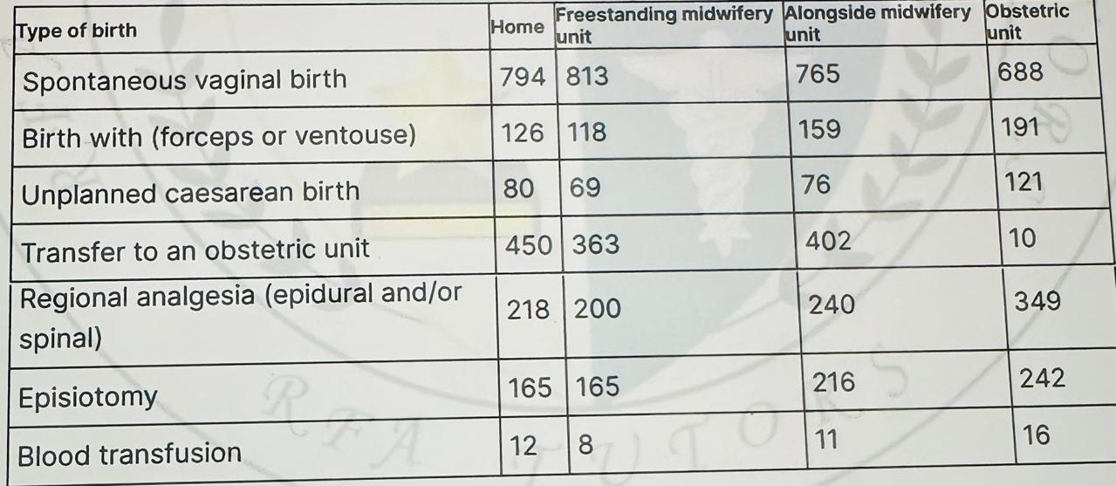

* For obstetric unit transfer to an obstetric unit, the 10 cases noted in table 4 are the estimated transfer rate from one obstetric unit to a different obstetric unit owing to lack of capacity or expertise. For regional anaesthesia, Blix et al. reported epidural analgesia and the Birthplace in England study reported spinal or epidural analgesia.

Table 5 Low-risk nulliparous women: Outcomes for the baby for each planned place of birth (by number of babies per 1,000 births)

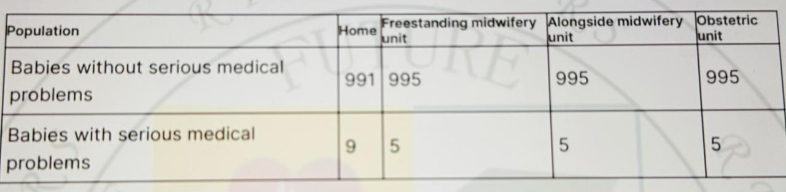

* Serious medical problems were combined in table 5: neonatal encephalopathy and meconium aspiration syndrome were the most common adverse events, together accounting for 75% of the total.

Stillbirths after the start of care in labour and death of the baby in the first week of life accounted for 13% of the events. Fractured humerus and clavicle were uncommon outcomes (less than 4% of adverse events).

Medical conditions and other factors that may affect planned place of birth

* Use tables 6 to 9 as part of an assessment for a woman choosing her planned place of birth:

tables 6 and 7 show medical conditions or other situations in which there is increased risk for the woman or baby during or shortly after labour, where care in an obstetric unit would be expected to reduce this risk

the factors listed in tables 8 and 9 are not reasons in themselves for advising birth within an obstetric unit, but indicate that further consideration of birth setting may be needed

discuss these risks and the additional care that can be provided in the obstetric unit with the woman so that she can make an informed choice about the planned place of birth. [2007, amended 2014

Table 6 Medical conditions indicating increased risk and suggesting planned birth at an obstetric unit

| Disease Area | Medical Condition |
| --- | --- |
| Cardiovascular | Confirmed Cardiac Disease  Hypertensive disorders |
| Respiratory | Asthma requiring an increase in treatment or hospital treatment  Cystic fibrosis |
| Haematological | Haemoglobinopathies such as sickle cell disease,Beta thalassaemia major.  History of Thromboembolic disorder.  ITP or other platelet disorder .  VWD.  Bleeding disorder in the woman and unborn baby.  Atypical Antibody that carry a risk for haemolytic disease of new born . |
| Endocrine | Hyperthyroidism.  Diabetes needing medication. |
| Infective | Hepatitis B or C with abnormal liver function test.  Toxoplasmosis - woman receiving treatment .Current active infection of chicken pox ,rubella  TB under treatment. |
| Neurological | Epilepsy  Myasthenia Gravis.  Previous Cerebrovascular Accident . |
| Gastrointestinal | Liver disease associated with current abnormal liver function test. |
| Psychiatric | Psychiatric disorder requiring current in patient care. |
| Immune | SLE.  Scleroderma. |
| Renal | Abnormal Renal function test.  Renal disease requiring supervision by renal specialist. |

Table 7 Other factors indicating increased risk and suggesting planned birth at an obstetric unit

| FACTORS | Additional Information |
| --- | --- |
| Previous  Complication | Unexplained still birth or neonatal death or previous death related intrapartum difficulty |
| Previous baby with neonatal encephalopathy |
| Pre eclampsia requiring pre term birth |
| Placental abruption with adverse outcome |
| Eclampsia |
| Primary PPH requiring additional treatment or BT |
| Caesarean birth |
| Shoulder Dystocia |

| Factor | Additional Information |
| --- | --- |
| Current  Pregnancy | Placenta praevia |
| Pre-eclampsia or pregnancy-induced hypertension |
| Preterm labour or preterm prelabour rupture of membranes |
| Placental abruption |
| Multiple birth |
| Anaemia hb less than 85 g/litre at the onset of labor |
| Confirmed IUFD |
| Substance misuse |
| Alcohol dependency requiring assessment or treatment |
| Gestational diabetes requiring medication |
| Malpresentation breech or transverse |
| Recurrent APH |
| SGA in this pregnancy less than 3rd centile |
| Abnormal fetal heart rate ,Umbilical or fetal doppler study |
| Ultrasound diagnosis of Oligo or Polyhydramnios |
|  |
| Previous Gynaecological History | Myomectomy |
| Hysterotomy |
|  |